Source ID: 950467817

Source Title: Journal of Gems and Gemmology

Current URL: <http://jogg.cug.edu.cn/en/article/current>

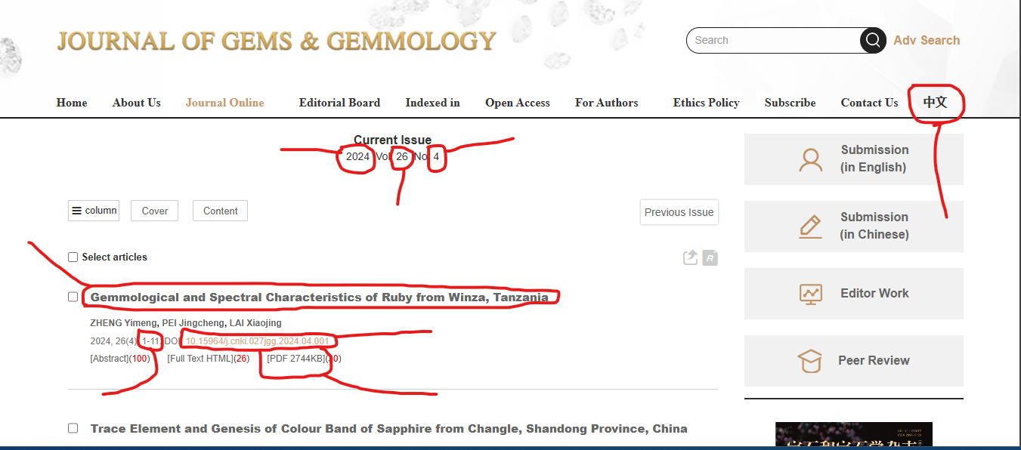

**Change Language here**

**PDF**

**DOI**

**Page Range**

**Title**

**Issue**

**Volume**

**Year**

**Both English & Chinese TOC need to Capture**